Pouya Shahverdi Moghaddam - 21245645

Lecturer : Dr Massoud Zolgharni

Logbook for AI

CP60034E

Table of Contents

Introduction 2

Seminar Week-1 : Introduction 2

Turing test 2

Rational act 2

Agent 2

Agent function 2

Environment 2

Rational behaviour 2

Percept 3

Action 3

Week 2 - Artificial Intelligence (Agents) 3

Question 1 3

Question 2 3

Question 3 4

Week 3 - Edison robot 5

Week 4 – Searching 6

Week 5 – Searching 7

Week 7 – Constraint Satisfaction Problems 11

Week 8 – Probability 14

Week-10: Bayes’ Net 16

Week 11 – Learning 17

Week 12 – Decision trees 18

# Introduction

In this logbook I will be demonstrating my understanding of Artificial Intelligence, I will be completing the weekly exercise’s from the seminars

# Seminar Week-1 : Introduction

Define in your own words the following terms:

## Turing test

The Turing test was a test developed by Alan Turing (known as the godfather of Computer Science and Artificial Intelligence) in 1950. This test was developed by Turing as a means of determining whether or not a computer is capable of thinking like a human or not in order to distinguish which is which.

## Rational act

Rational act is the act of doing the correct thing in order to achieve the end goal by using the maximum information available to you.

## Agent

An agent within artificial intelligence can be anything as perceiving it’s environment with sensors and later on acting up the environment through actuators.

## Agent function

An agents function is used to described the behaviour of the agent.

## Environment

Ag

## Rational behaviour

Rational behaviour like the name suggests simply put as doing the right thing, this in A.I specifically means that when a programmed machine does what it’s meant to do based on all the information it has available. E.g a robot vacuum cleaner that is programmed to clean at a certain time does that job correctly, its behaviour is rational.

## Percept

In artificial intelligence a percept is the input where an intelligent agent is perceiving at any given moment. Examples of this can be a camera on a smartphone that uses A.I technology to edit the photos on in a robotic vacuum cleaner there will be sensors around the device to see where it is going. This again is the percept of the device. The sensor is input of information to the device

## Action

Action is the job that is carried out by an artificial inelegance agent. This all depends on the what the exact job is.

# Week 2 - Artificial Intelligence (Agents)

Question 1

Define in your own words the following terms:

• Performance measure

Performance measure is to measure the success of the agent’s behaviour. This can be measured in a number of way depending on the agent. E.g the vacuum cleaner’s performance measure can be seen as the amount of time it takes for it to do the task it’s been assigned or how much dirt it has clean up.

• goal-based agent

It’s when an agent it trying to reach its goal. In the exam of the vacuum its goal would be to clean up the roam in a certain time and speed.

Question 2

For each of the following activities, give a PEAS description of the task environment

• Automated taxi driver

Performance – MPG, Route, Time, Efficiency, Millage, passengers transported

Environment – Weather conditions, road conditions, motorway

Actuators – steering arms, breaks, honk, doors

Sensors – Parking censors, cameras, road sensors, infa-red, lasers

• Playing a tennis match

Performance –

Environment – wind, court material,

Actuators – arm joints,

Sensors – infa red, sensors, cameras.

Question 3

Write a pseudo code program for a goal-based agent. The goal of the agent is to find the exit of a labyrinth.

• The agent is not omniscient

• The agent can sense if it is next to a wall (in front, left or right) • The agent can turn 90 degrees to the right or

• The agent can drive 1-unit forward

The maze is constructed of paths that are 1 unit across (wide) S

how a maze of your choosing and illustrate the path taken from start to exit according to your program (example shown here)

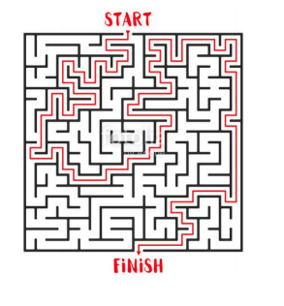

IF (Wall= Left)

IF (NO WALL FRONT)

Move Forward

else

Turn Left

Else

Turn left

The pseudo code above demonstrates how it would be move through.

# Week 3 - Edison robot

Question 1

Map the following Agent-terms to the features of the Edison robot:

Sensors - The sensors on the Edison Robot are as follows: Right and left light sensors, Infrared LED, Stop and start Button, play button, Barcode Scanner, Tracking Line sensor, recording button, Obstacle detector, Buzzer/Clap detector sensor and Control driving by remote.

Actuators - Wheels, Led lights and the sound players via the speakers.

Environment – The environment can be anything depending on the location, examples can be carpeted/wooden/tiled floors, Desks, the street etc.

Percept – line for the robot to follow, barcode to be scanned, light, sound, touch.

Goals – The goal for the Edison robot is to follow instruction given such as following a line, recognise gestures, avoid obstacles, play music all whilst learning it’s environment.

Question 2-3. For this questions I familiarised myself with the robot and the application and I also made a number of program via the inhouse app and the pre programmed scannable programs.

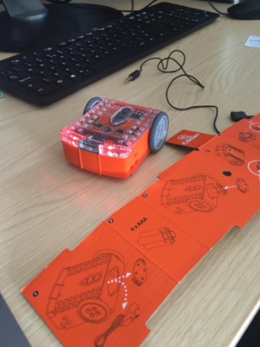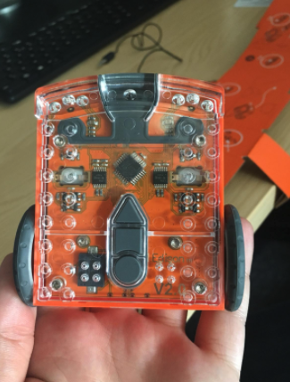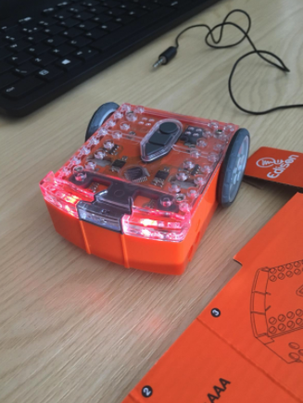

# Week 4 – Searching

1) Define in your own words the following terms: state, state space, search tree, search node, goal, action, transition model, and branching factor.

I will be using an example of robotic vacuum cleaning different rooms (one to three) in order to explain the flowing terms.

State – State is determined when you have an agent (vacuum) and the location of the dirt. This describes what is happening at the time in an environment. For example, if there were 3 rooms with all rooms containing dirt and one of the rooms containing the robot, this would be the state of the rooms.

Goal – The goal is the agent’s main job. In the case of our robotic vacuum the goal can be to clean room 1 and then move to room 2 and then 3.

At the end you can have a goal test, this is used to determine if the agent has done its job properly.

State Space - It can also be described in a manner where the vacuum would have an initial state and goal state. So the initial state can be described as the agent being in room 1 and cleaning room 1 with goal state being the vacuum moving and cleaning room 3.

Search tree – a search tree is a model that be used to describe and show the sequence of action if a algorithm. The tree will contain a start root which will be the initial state, branches that represent decisions, nodes that correspond the state.

Search node- Nodes are structures in search trees and contain date and links with other nodes.

Action – This is the instructions given to the agent to perform a task. In the example of the vacuum the action can be. Right, suck, right, suck. this will make the robot move to the right room, and suck and clean the room and again move to the right room and suck and clean the room.

Transition model – This is the description of what each action does, and it is shown by a model which is known as transition model.

Branching factor – In a search tree, the branching factor is the number of children at each node. So the max nodes after achieving the successor.

2) Start thinking about a possible problem to be solved with the use of an Edison bot (and Lego tech, if needed). Document your problem search with notes.

A program I would create with the Edison robot would be for the robot to follow a path to 3 rooms and determine which room should the robot end up staying by reading a barcode.

State = State is determined by the agent and the location of the barcode.

Initial state = room 1

Action = Left, Right, Scan

Transitional model = Action have their expected effect.

Goal test = find and scan barcode

Path goal = 1 per action

# Week 5 – Searching

1) Explain the Graph-Search algorithm.

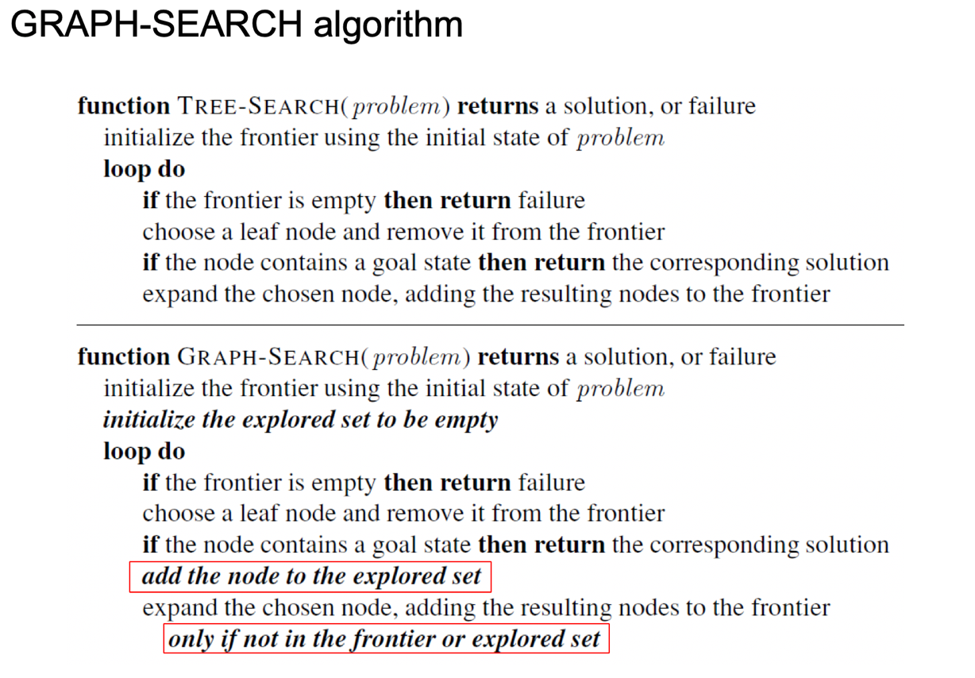

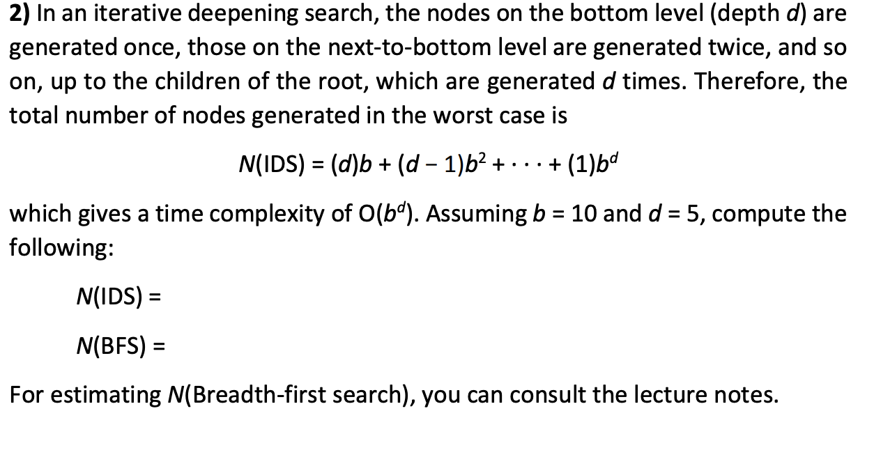

N (IDS) = (10)5 + (5 – 1) + 102 + 103 + ( 5 – 3 ) 104 + ( 5 – 4) 105 = 123.450

N(BFS) = 101 + 102 + 104 + 105 = 111.110

Week 6 – Searching

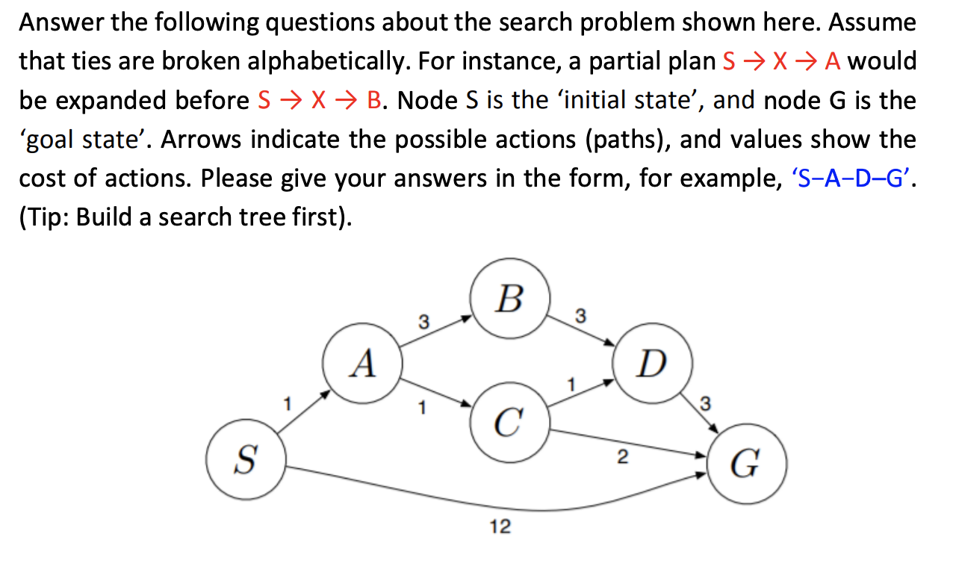

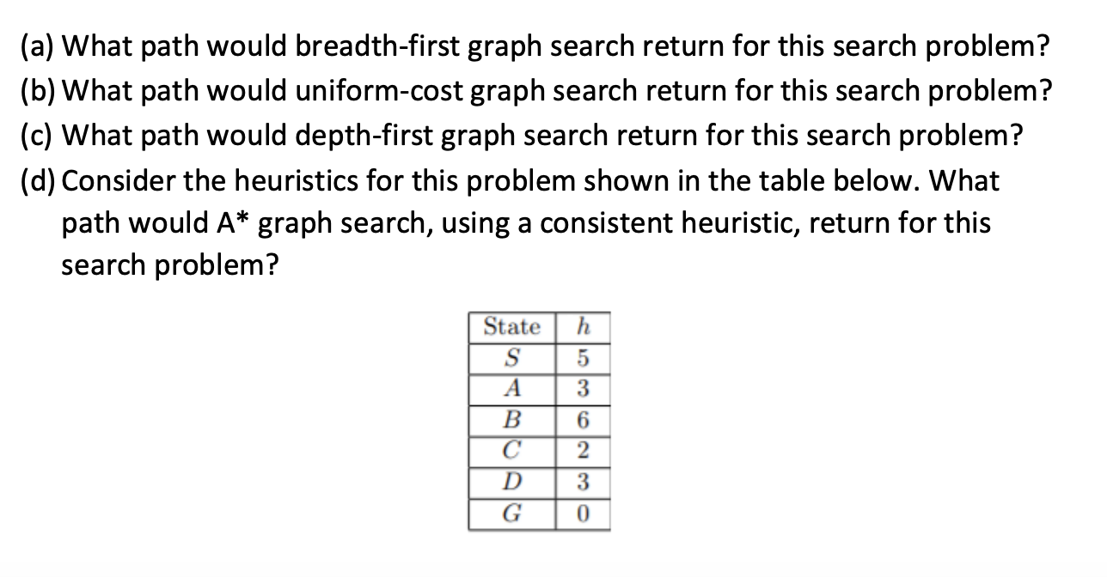

1. S – G
2. S – A – C – G
3. S – A – B – D – G
4. S – A – C – G

# Week 7 – Constraint Satisfaction Problems

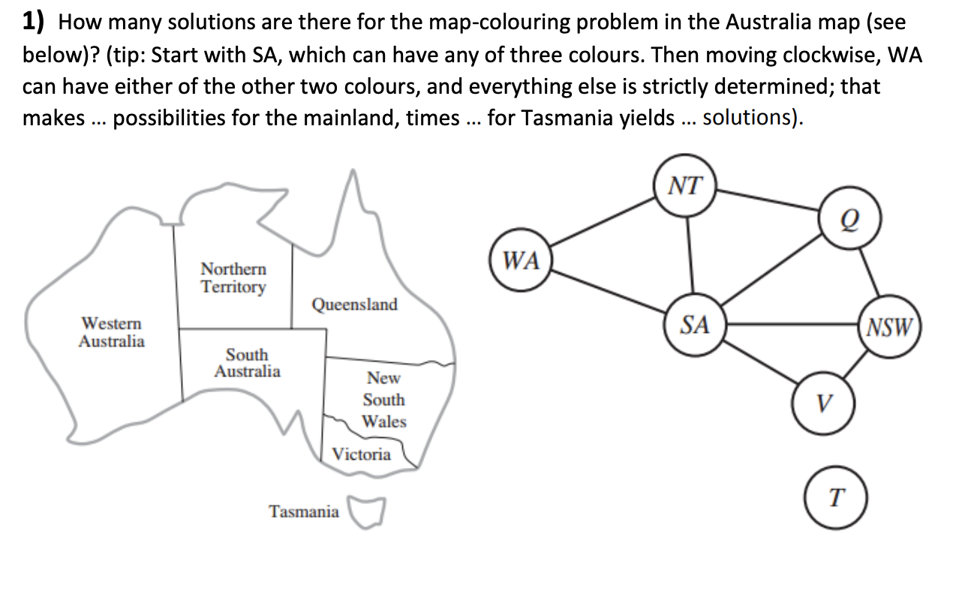

T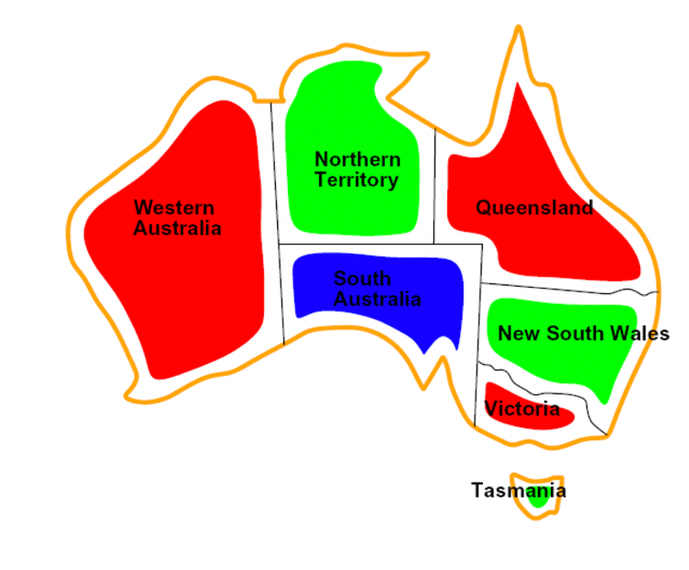

The first part to solving this problem is choosing the colours for the region. We have to make sure no neighbouring region will have the same colour, with the colours being: Red, Green and Blue.

As we are starting with SA and going clockwise we can associate SA with the colour Blue and therefore we are left with Red and Green and WA will be associated with Red . At this point the remaining states of Q, NSW, V and T can be easily coloured without repeating the same neighbouring colour, especially T as this node is not connected and can be associated with any colour. So the combination is as follows.

3 x 2 = 6, - 6 colour possibilities for the mainland Australia and as Tasmania is not connected and any colour can be associated with that we can have the 6 colour possibilities x 3 (Tasmania colour possibilities) – 6 x 3 = 18

2) Explain why it is a good heuristic to choose the variable that is most constrained but the value that is least constraining in a CSP search.

The name for this is MRV, Minimum Remaining Values heuristic. This is due to when a variable is selected the algorithm has to decided according to the order to have it’s values examined.

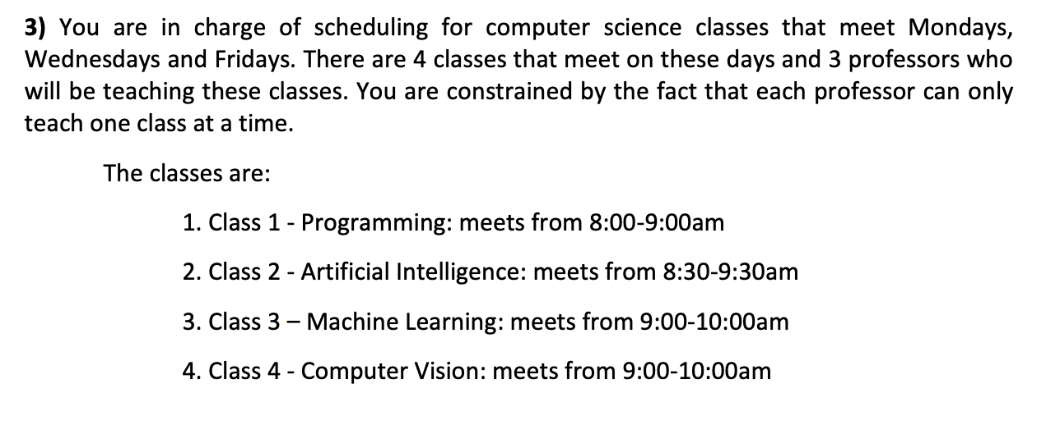

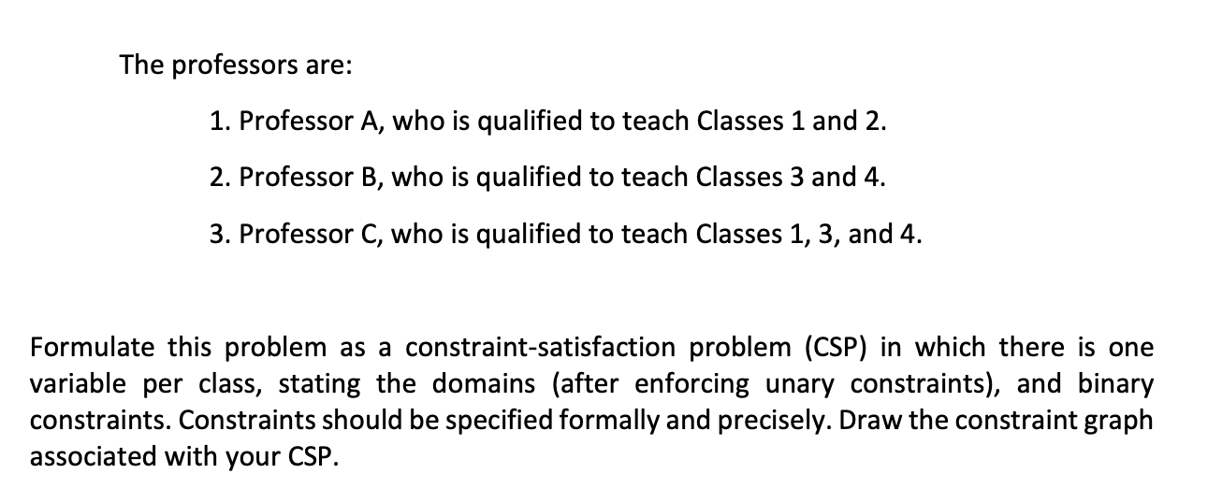

Variables = Class 1, Class 2, Class 3, Class 4

Values = A, B, C,

Constraints = C1 ≠ C2 , C2 ≠ C3 , C2 ≠ C4 , C3 ≠ C4

Therefore

|  |  |
| --- | --- |
| Variables | Values |
| C1 | {A, C} |
| C2 | {A} |
| C3 | {B,C} |
| C4 | {B,C} |

# Week 8 – Probability

1. What are causes of uncertainty in an AI system?

There are many uncertainties in A.I but the main ones could be too much data, ambiguous data, missing data, unreliable or in general bad data that can affect the agent.

There could also be issues with the agent breaking down and not working.

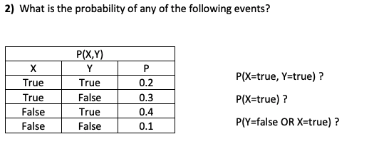

**2)** What is the probability of any of the following events?

P(X=true, Y=true) ? P(X=true) ?

0.2 or 20%

P(X=true) ?

0.5 or 50%

P(Y=false | X=true) ?

0.6 or 60%



P (X=true | Y=true) = $\frac{P( x=true, Y=true )}{P ( Y=true)}$ = $\frac{0.2}{0.6}$ = $\frac{1}{3}$ = 0.333

P (X=false | Y=true) = $\frac{P( x=false, Y=true )}{P ( Y=true)}$ = $\frac{0.4}{06}$ = $\frac{2}{3}$ = 0.666

P (Y=false | X=true) = $\frac{P( y=false, x=true )}{P ( x=true)}$ = $\frac{0.3}{0.5}$ = $\frac{6}{10}$ = 0.6

**4)** Using the probability distribution table below, work out the following probabilities: 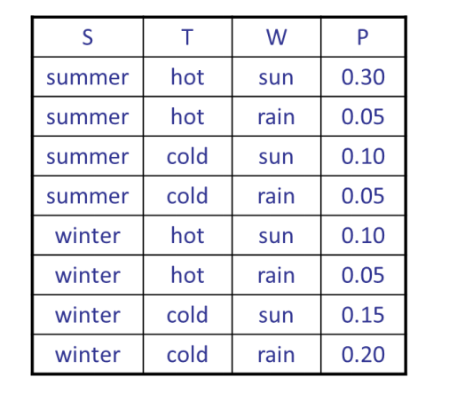

P(W = sun)?

0.3 + 0.1 + 0.1 _ 0.15 =

0.65  
P(W = rain)?

0.05 + 0.05 + 0.05 + 0.2 =

0.35

P(W=sun | S=winter)?

0.25/0.5 = ½ = 0.5

P(W=sun | S=winter, T=hot)?

0.1/0.15 = 0.66666

# Week-10: Bayes’ Net

1. For the example of tossing a normal (fair) coin, calculate the Probability of having the same side of the coin in two consecutive tosses. Justify your answer.

The probability of coin one consecutive toss will be 0.5 or 50% and two consecutive side will be 0.25 as 0.5x2= 0.25

2) Draw a typical Bayesian network for the following domain of slippery pavement problem:

* •  Season
* •  Raining
* •  Sprinkler
* •  Wet pavement
* •  Slippery pavement

3) You have a new burglar alarm installed at home. It is fairly reliable at detecting a burglary, but also responds on occasion to minor earthquakes. You also have two neighbours, John and Mary, who have promised to call you at work when they hear the alarm. Draw a Bayesian network for this domain.

# Week 11 – Learning

1) What is the “learning element” in an agent and what is its function? Consider using a diagram.

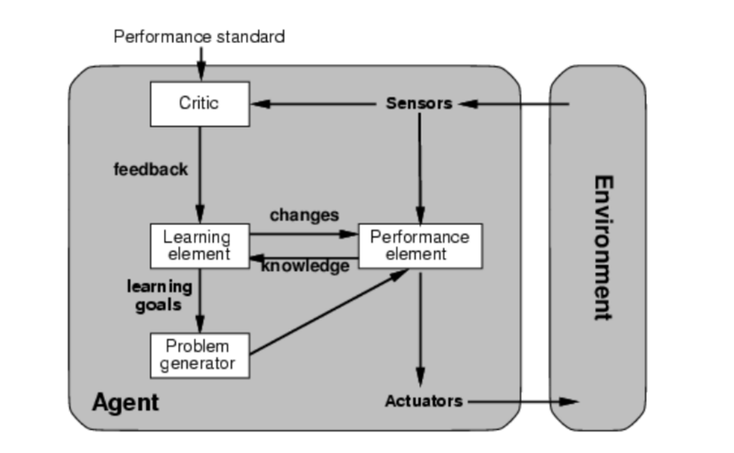

The above diagram shows an agent. A learning agent two elements, a performance element and a learning element. The learning aspect allows the agent to adapt to new circumstances and detect patterns. This will add knowledge and improve the system.

2) Describe unsupervised learning, and provide one example for its application.

Unsupervised learning is when patterns are being learnt in the input. And when no specific output values being supplied.

For example if a company decides to see which are their best-selling item of cloths based on the sizes they sell, they can observe a graph and look at the clustered date in the graph and make their decision from there.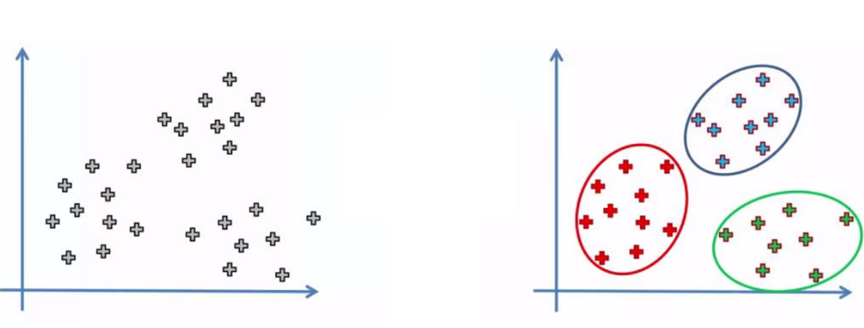

3) Is regression analysis a supervised or unsupervised learning approach? Justify tour answer.

Regression analysis is supervised learning because there is a dependable variable and the values have a target output.

4) Considering Ockham’s razor principle, which one of the 2 possible ways would you use to explain why the tree fell down? Justify your answer.



Ockham’s razor principle states that all things being equal but the simplest explanation us usually the correct one. If we consider the chances of option two we can assume it can be a 1/1000000 chance of that happening whilst the likelihood of scenario one happening is 1/100. So I would choose scenario 1 based on that principle.

# Week 12 – Decision trees

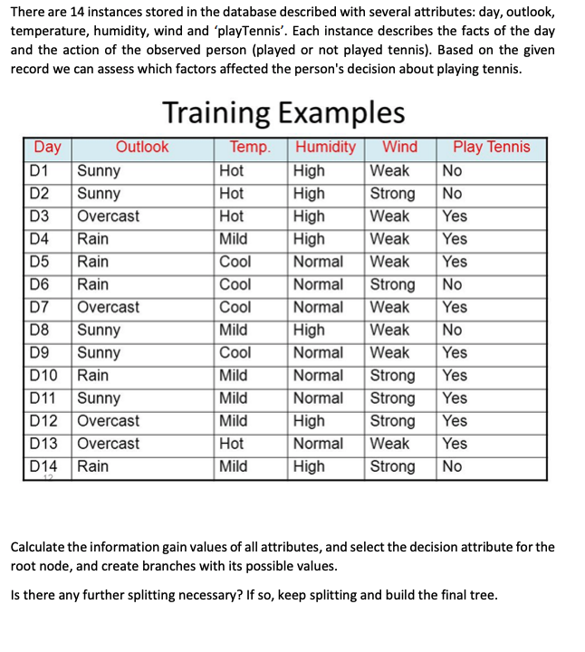





Target attribute is Play tennis:

yes = 9, no = 5 || Total play tennis = yes + no = 9 + 5 = 14

Wind:

Strong = 6, weak = 8 || total = 6 + 8 = 14

Humidity:

High = 7, normal = 7 || total = 7 + 7 = 14

Temperature:

Hot = 4, mild = 6, cool = 4 || total = 14

Outlook:

Sunny = 5, overcast = 4, rain 5 || total = 14

Initial entropy of the training sample:

𝑖𝑛𝑓𝑜𝐺𝑎𝑖𝑛(𝑆, 𝑇𝑒𝑚𝑝) = 0.403 log2 log2 - log2 log2 = 0.0292







Decision tree

Final decision tree

